Extrusive and Intrusive volcanic features
Extrusive volcanic features are formed by lava and ash at the surface of the Earth. These include different types of volcanic cones and basalt plateaux.
Volcanic cones: shield cones, viscous lava domes, ash cones, composite cones and calderas. See text)
Basalt plateau: these are formed when basic lava flows to the surface over a wide area, often emerging from a vent or fissure. This produces a wide flat plateau e.g. the Deccan plateau in India
Intrusive volcanic features are formed by magma cooling and solidifying beneath the surface. Sometimes they are eventually exposed when the rocks above are removed by erosion.
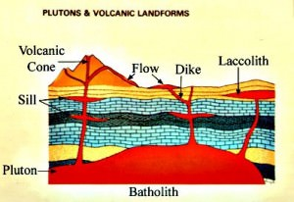

A sill is formed by magma flowing horizontally between two rock layers and roughly parallel to the surface.
A dyke (dike) is a vertical sheet of igneous rock formed by magma moving directly upwards towards the surface.
A neck or plug is a vertical pipe of rock, formed when the molten material in the vent of a volcano cools and hardens.
A batholith is a much larger intrusive feature, formed when a large underground reservoir of molten rock cools and hardens below the surface.
Laccoliths are much smaller ponds of magma that solidifies beneath eth earth’s surface.
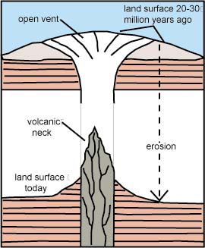
Volcanic features change over time: (Examples- St. Vincent, Grenada and St. Lucia)
- Hills remain where extinct volcanoes once were active
- The small rivers and streams flow down the sides of volcanic cones have steep, narrow valleys
- Dykes form ridges of high ground
- Calderas leave large domes in the landscape
- Some calderas are now the site of lakes such a Gran Etang in Grenada,
- Old pyroclastic flows have built up layers over time to form plateaux.
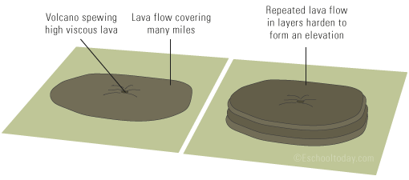
Rewrite this note and draw the accompanying diagrams in your notebook!

